**Kafka And Spark Streaming Simple Program**

**KAFKA WORD COUNT**

Please find the files attached below :





The extra jar file required to run the kafka and spark streaming :



**CREATE KAFKA TOPICS**

Please find the mentioned below command for the creation of topic.

bin/kafka-topics --create --zookeeper ip-20-0-21-196.ec2.internal:2181 --replication-factor 1 --partitions 1 --topic wordcount_kafka12_debmalya

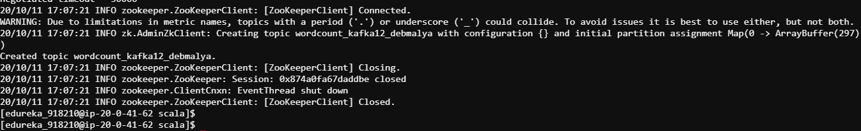

**CONSUMER-PRODUCER BROKER LIST**

bin/kafka-console-producer --broker-list ip-20-0-31-4.ec2.internal:9092 --topic wordcount_kafka12_debmalya

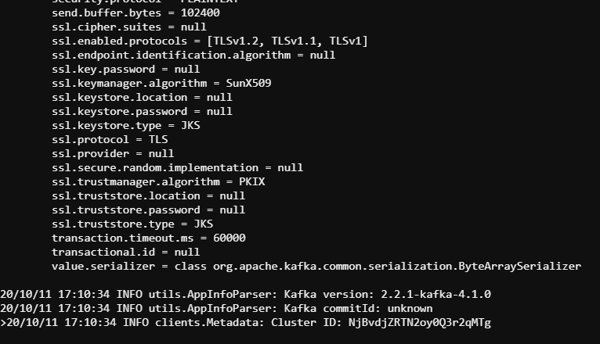

spark2-submit --class KafkaWordCount --master local[4] /mnt/home/edureka_918210/KafkaWordCount/src/main/scala/target/spa

rk-kafka-project_2.10-1.0.jar ip-20-0-21-196.ec2.internal:2181 group wordcount_kafka12_debmalya 4

